
a
Company
Logotype

Cone Beam Computed Tomography- Report



Porur Dental X-rays & CBCT

Patient Name : Mr. Devaraj | Date of Report : 02.07.2024
Age/ Gender : 65 years/ Male | Region of Interest : CBCT Maxilla
Referring doctor: Dr. R. Joshua | Indication : Nil
Clinical Notes: Nil
PATIENT INFORMATION

CBCT- Maxilla provided
CBCT – IMAGE DETAILS

RADIOGRAPHIC INTERPRETATION

- Fractured crown: 15.
- Root stumps: 16
- The maxillary alveolar ridge is present with normal trabecular pattern.
- Hyperdense crown structure in relation to 26, 28..
- Presence of hyperdense restorative material within the pulp canal extending upto the apical region in relation to 26, 28.

IMPLANT ASSESSMENT

 | 15 region | 16 region | 17 region | 27 region
Mid- Crestal (in mm) | 10.69 | - | 5.66 | 11.34
Distance between the alveolar ridge and floor of the maxillary sinus (in mm) | 6 | 3.34 | 14.65 | 6.76

RADIOGRAPHIC IMPRESSION

- Partially edentulous maxillary alveolar ridge.
- Root canal treated tooth with crown : 26, 28
- Fractured crown: 15.
- Root stumps: 16

Kindly correlate with clinical findings


IMAGES FOR REFERENCE

RECONSTRUCTED PANORAMIC VIEW
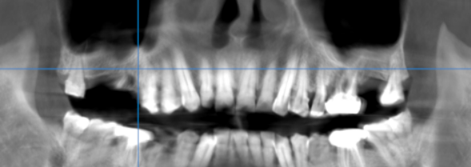

3-DIMENSIONAL VIEW

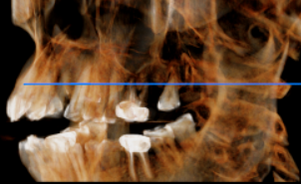
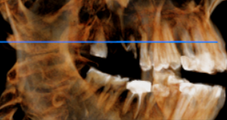

CROSS SECTIONAL VIEW

15 region | 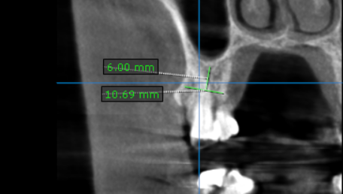
16 region | 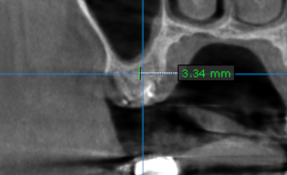
17 region | 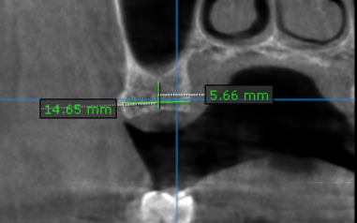
27 region | 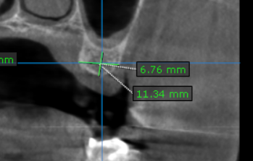

**** End of report ****

